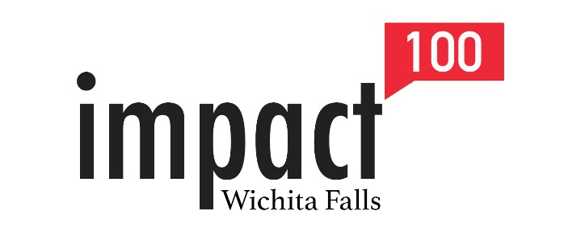

EMBARGOED RELEASE UNTIL EVENT CONTACT: Leslie Schaffner 940.733-4035
Thursday, January 16, 2020 @ 6:30PM leslie@sw.rr.com
GRANT CONTACT: Ruth Jones 940.613.5101 grants@impact100wf.org

IMPACT 100 WICHITA FALLS REVEALS INAGURAL GRANT AWARD
ISSUES CALL FOR APPLICATIONS

(WICHITA FALLS, TX)—Impact 100 Wichita Falls announced it will award one $59,000 grant to a nonprofit organization in the greater Wichita Falls area on May 28th. The announcement came during Impact 100’s “Big Reveal,” on Thursday, January, 16th, when members learned the final number of women who joined the organization during the 2019 membership drive.

This is the inaugural granting year for Impact 100 Wichita Falls. The organization is currently comprised of 59 women from around the area with an interest in improving the community through strategic philanthropic investment. Each member has committed a minimum of $1,000 to the grant. The concept is to provide funding for critical needs, new ventures, and innovative ways to solve social problems in the area.

“The power of women giving as one through high-impact grants allows us to have a profound influence on improving the quality of life in our service area,” said Paula Perkins, President of Impact 100 Wichita Falls. “Pooling our donations and working together to be strategic philanthropists, we are able to return 100% of our members’ donations to effect sustainable social change.”

Future plans are to grow the membership to offer a $100,000 grant, with a goal of, one day, awarding multiple $100,000 grants in five focus areas of Arts & Culture; Education; Environment; Recreation & Preservation, Family; and Health and Wellness.

Charitable 501(c)(3) organizations interested in applying for the first Impact 100 Wichita Falls grant will have until Friday, February 28th to complete the online application. Interested nonprofits are encouraged to review the grant criteria and FAQs to determine eligibility before applying. That information can be found on the organization’s website www.impact100wf.org/grants. Eligible applicants are also encouraged to attend one of two informational workshops scheduled for Friday, January 31st at Midwestern State University, in Room 129 of the Dillard College of Business. The sessions will be offered at 10 a.m. and 2 p.m. Reservations for the workshops are requested at grants@impact100wf.org.

For more information about Impact 100 Wichita Falls, or to become a member, visit www.impact100wf.org or follow us on Facebook or Instagram @Impact100wf.

###

